Task 2 : Phishing email

ANSWER :

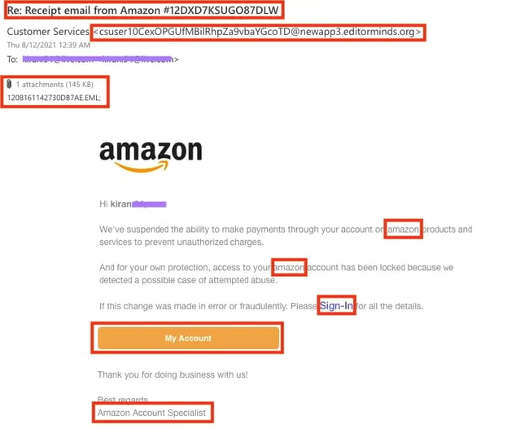

* WE CAN IDENTIFY EASILY THROUGHOUT THE RED FLAG – AND LEGITIMATE IS IT GENIUINE OR NOT.
* THE SENDER EMAIL ID – NOT SEEMS LIKE AN OFFICIAL EMAIL ID OR CORPORATE ID
* The MALCIOUS ATTACHMENT – FORCED US TO CLICK IT NOW – IT CONTAINS TROJAN , WORM ETC.
* THE AMAZON TEXT HAS GRAMMITICAL MISTAKE AND TYPES IN THE WAY LIKE SOCIAL ENGINEERING

TARGET PURPOSE BY HACKER

* TO HACK YOUR ACCOUNT
* WHEN U FILL YOUR CREDENTIALS , THEY CAN THEFT YOU AND TARGET YOUR ACCOUNT WHICH HAS PERSONAL DETAILS AND YOUR CREDIT CARD DETAILS
* USER CAN BE A VICTIM WHEN HE FILLS THE FORM USING SUSPICIOUS LINK AND CAN HAVE THE FINANCIAL LOSS